**WB PMU Attendance Report December 2022**

**Details Required for Processing the Payment**

1. ***Details of Project Start***

|  |  |  |
| --- | --- | --- |
| **State** | **MoU date** | **Team placement date** |
| West Bengal | 24/12/2021 | 20/01/2022 |
|  |  |  |

1. ***Attendance of Team***

|  |  |  |  |  |  |
| --- | --- | --- | --- | --- | --- |
| **Sl. No.** | **Date** | **PMU Manager** | **Attendance** | **Business Analyst** | **Attendance** |
|  | 01-Dec-22 | Kaushik Mukherjee | P | Santanu Karmakar | P |  |
|  | 02-Dec-22 | Kaushik Mukherjee | P | Santanu Karmakar | P |  |
|  | 03-Dec-22 | Kaushik Mukherjee | P | Santanu Karmakar | P |  |
|  | 05-Dec-22 | Kaushik Mukherjee | P | Santanu Karmakar | P |  |
|  | 06-Dec-22 | Kaushik Mukherjee | P | Santanu Karmakar | P |  |
|  | 07-Dec-22 | Kaushik Mukherjee | P | Santanu Karmakar | P |  |
|  | 08-Dec-22 | Kaushik Mukherjee | P | Santanu Karmakar | P |  |
|  | 09-Dec-22 | Kaushik Mukherjee | P | Santanu Karmakar | P |  |
|  | 10-Dec-22 | Kaushik Mukherjee | P | Santanu Karmakar | P |  |
|  | 12-Dec-22 | Kaushik Mukherjee | P | Santanu Karmakar | P |  |
|  | 13-Dec-22 | Kaushik Mukherjee | P | Santanu Karmakar | P |  |
|  | 14-Dec-22 | Kaushik Mukherjee | P | Santanu Karmakar | P |  |  |  |
|  | 15-Dec-22 | Kaushik Mukherjee | P | Santanu Karmakar | P |  |  |  |
|  | 16-Dec-22 | Kaushik Mukherjee | P | Santanu Karmakar | P |  |  |  |
|  | 17-Dec-22 | Kaushik Mukherjee | P | Santanu Karmakar | P |  |  |  |
|  | 19-Dec-22 | Kaushik Mukherjee | P | Santanu Karmakar | P |  |  |  |
|  | 20-Dec-22 | Kaushik Mukherjee | P | Santanu Karmakar | P |
|  | 21-Dec-22 | Kaushik Mukherjee | P | Santanu Karmakar | P |
|  | 22-Dec-22 | Kaushik Mukherjee | P | Santanu Karmakar | P |
|  | 23-Dec-22 | Kaushik Mukherjee | P | Santanu Karmakar | P |
|  | 24-Dec-22 | Kaushik Mukherjee | P | Santanu Karmakar | P |
|  | 26-Dec-22 | Kaushik Mukherjee | P | Santanu Karmakar | P |
|  | 27-Dec-22 | Kaushik Mukherjee | P | Santanu Karmakar | P |
|  | 28-Dec-22 | Kaushik Mukherjee | P | Santanu Karmakar | P |
|  | 29-Dec-22 | Kaushik Mukherjee | P | Santanu Karmakar | P |
|  | 30-Dec-22 | Kaushik Mukherjee | P | Santanu Karmakar | P |
|  | 31-Dec-22 | Kaushik Mukherjee | P | Santanu Karmakar | P |

1. ***Photo ID with Address Proof of SIDBI-PMU (GT Team)***

**Kaushik Mukherjee – Aadhar Card**

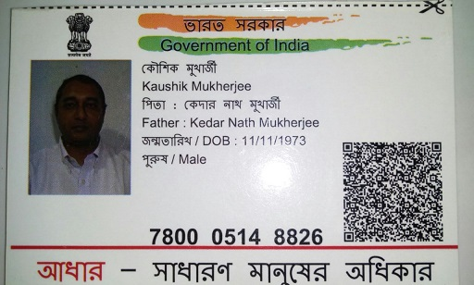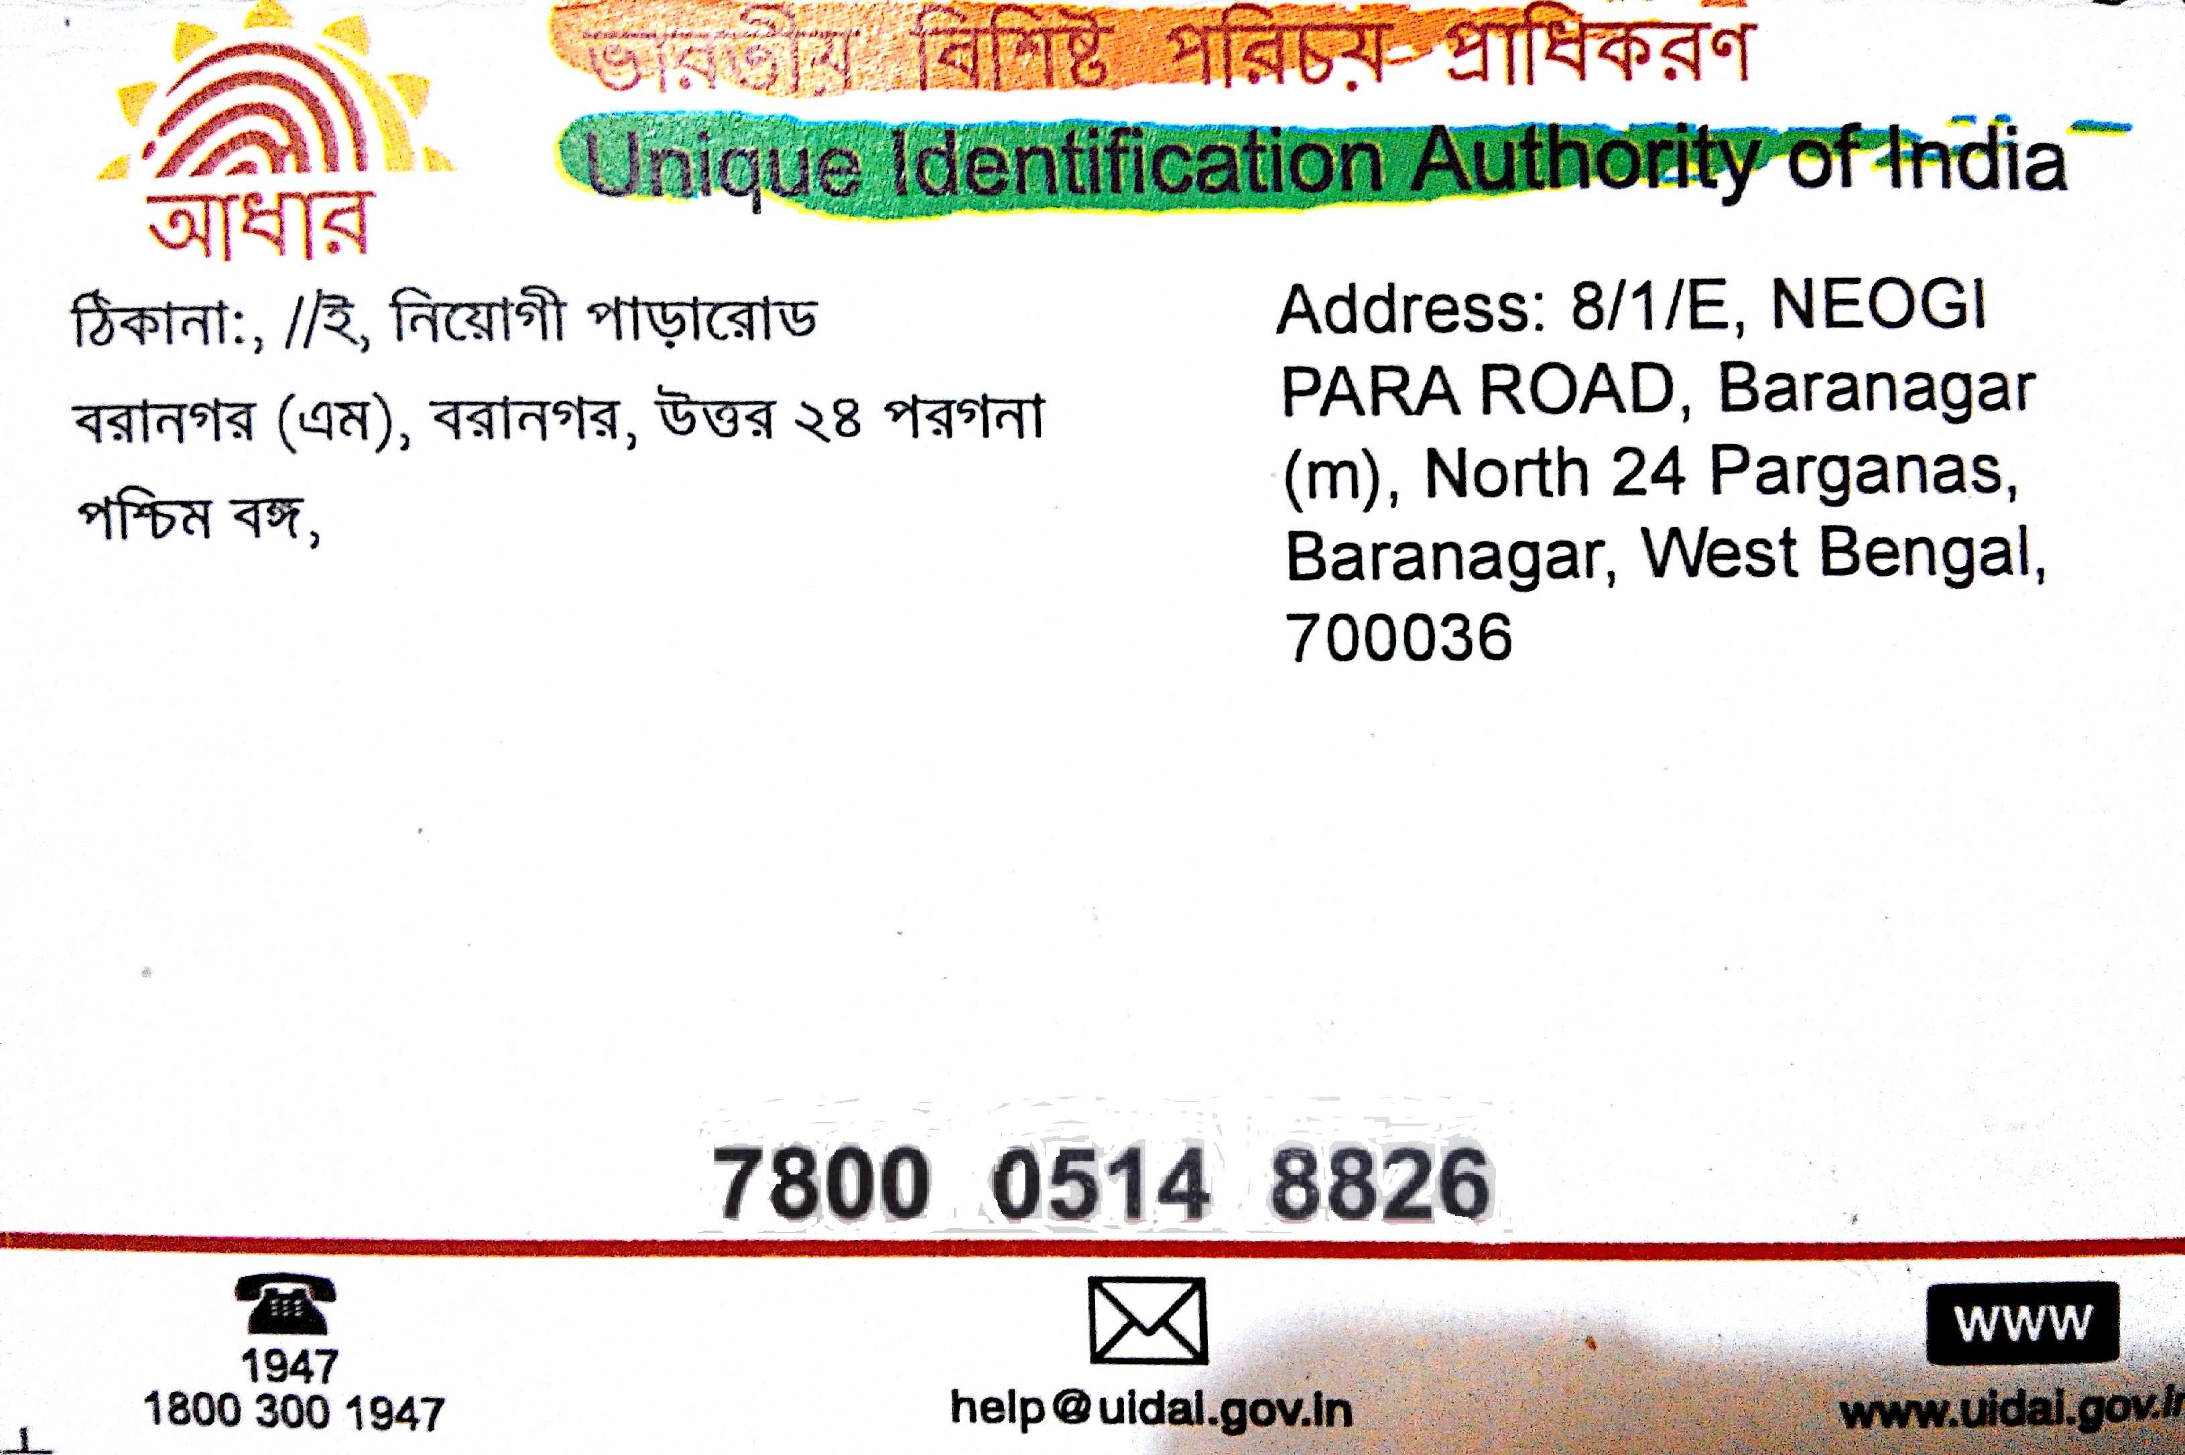

**Santanu Karmakar – Aadhar Card**

